**Assignment Fulfilment**

Kevin Del Rosario

Diploma in Information Technology, Kaplan Higher Education Institute

IT46 IDC: Principles of Information Systems and Data Management

Mr. Satish Kumar Sarraf

February 7, 2024

**Introduction**

Amarah’s Corner is a Fast-Food Restaurant SME based on the Philippines. They specialize in Pizzas and offers a wide range of food that are affordable and filling meals. They aim to be one of the most competitive Pizza Place nationwide by serving one of the best pizzas that will satisfy your cravings. We are committed to using sustainable processes, procuring premium foods, and upholding strict food safety regulations. Our staff provides courteous, timely service so that every client is happy and ready to come back. Our goal is to create an environment at work where cooperation, innovation, and constant progress are valued. By adhering to our mission, we hope to be a constructive influence in the communities we serve and provide our patrons with a satisfying and unforgettable dining experience.

The speed and service of a Fast-Food Restaurant is a one of the main contributing factors of a Restaurant’s reliability. A restaurant’s main way to receive orders is through the POS (Point of Sale) System. Amarah’s Corner uses the Zeoniq System for taking orders. Cashiers are trained to use the Zeoniq System to maximize its potential and reduce the waiting time of customers. The cashiers take orders from customers and will adjust the meal according to the requests of the customer which will then be keyed in inside the POS. This makes sures that the orders will be accurate and stored in the Database. At the end of the Day, the Zeoniq System will provide Business Analytics to the Restaurant Manager such as Cash Orders, Credit Card Orders, number of Soda Orders, number of Burger orders, and so on.

**Implementation of New Information System: Self-Ordering Kiosks**

However, there is a current trend in the market which most of the Big Companies are already using. That is Self-Ordering Kiosks. Although the Cashier-Customer system is a good way to receive orders, there are some issues that comes with it:

Miscommunication: Staff and Customers can sometimes miscommunicate whether it be language barrier or misunderstanding of certain words, resulting in the food being prepared wrongly and/or customers getting angry.

Wait Times: Customers can experience a longer waiting time especially during peak hours due to having to queue and taking orders manually.

Ordering Errors: Humans are bound to make mistakes. Cashiers may forget to put customer’s request which will lead to wrong orders.

Self-Ordering Kiosks from Zeoniq is proposed to not replace but provide an upgrade to Amarah’s Corner current System. It will address the problems of the current system to provide a better customer experience, flow of food delivery, and food quality. Zeoniq’s Self-Ordering Kiosk provides: Portability across multiple platforms, E-Wallet and Credit Card Payments, Cloud Synchronization, and Loyalty Program.

**Flow Chart**

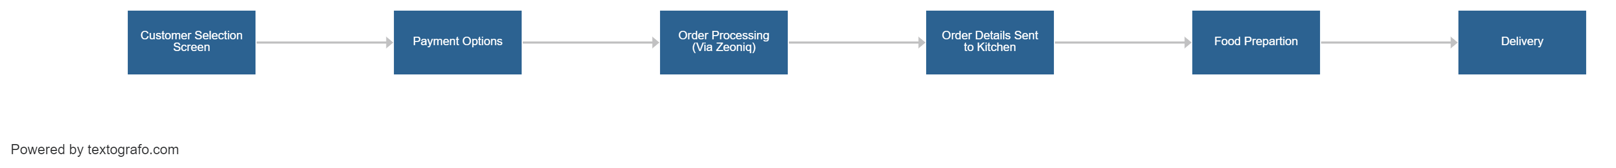

Self-ordering kiosks let Amarah's Corner streamline its ordering procedure. Customers may browse an interactive menu and use real-time visuals to personalize their order. Upon order confirmation via the touchscreen, a number of payment methods, such as credit card and e-wallet, are accessible. In order to provide the kitchen staff with a clear digital copy, order information are transferred to the backend system. Special requests are noted by the staff as they prepare the order, which helps to cut down on errors. The system alerts consumers for pick-up when it's finished. The cloud synchronization facilitates data analysis for well-informed business decisions, and the linked rewards system immediately refreshes points that are visible on the customer's account.

|  |  |
| --- | --- |
| **Class** | **Description** |
| Customer | Represents individuals interacting with the Self-Ordering Kiosk, with attributes like name and account. |
| SelfOrderingKiosk | Represents the kiosk itself, handling menu display, order customization, and payment processing. |
| Order | Represents an individual order, including details like selected items, customization, and status. |
| PaymentOption | Represents various payment methods, including E-Wallet and Credit Card, as part of the ordering process. |
| BackendSystem | Manages the processing and storage of order details, ensuring accurate communication with the kitchen. |
| KitchenStaff | Represents the staff responsible for preparing orders, interacting with the BackendSystem for instructions. |
| LoyaltyProgram | Manages customer loyalty points and benefits, linked to the Customer class. |
| Cloud | Represents the cloud storage for synchronizing order data, sales, and customer preferences. |

**Customer**

Attributes: customerID, name, accountDetails

Relationships: Makes (1) Order

**SelfOrderingKiosk**

Attributes: kioskID, touchscreenInterface

Relationships: Manages (1) Order, Accepts (0..1 or 1) PaymentOption

**Order**

Attributes: orderID, orderDetails, orderStatus

Relationships: BelongsTo (1) Customer, PlacedAt (1) SelfOrderingKiosk, SentTo (1) BackendSystem

**PaymentOption**

Attributes: paymentID, paymentMethod

Relationships: UsedIn (0..1 or 1) Order

**BackendSystem**

Attributes: systemID, dataProcessing

Relationships: Processes (1) Order, CommunicatesWith (1) KitchenStaff

**KitchenStaff**

Attributes: staffID, preparationSkills

Relationships: ReceivesInstructionsFrom (1) BackendSystem

**LoyaltyProgram**

Attributes: loyaltyID, loyaltyPoints, benefits

Relationships: LinkedTo (1) Customer

**Cloud**

Attributes: cloudID, storedData

Relationships: Synchronizes (1) OrderData, Sales, CustomerPreferences

**Comparison of Systems**

Amarah's Corner must make a critical decision about the purchase of new systems, comparing the advantages of keeping its Zeoniq POS System and the suggested installation of more feature-rich Self-Ordering Kiosks. Due to its established infrastructure, the Zeoniq POS System, which is already well-established within the company, provides familiarity and the possibility of cost savings. But there are disadvantages as well, such as the potential for misunderstandings, higher wait times during busy times, and the chance of placing the wrong order.

Conversely, the Self-Ordering Kiosks that are envisioned offer a noteworthy enhancement to the client experience. Interactive menus, real-time customizing visuals, and the possibility of shorter wait times are all offered by these kiosks. Direct client involvement reduces ordering errors and improves accuracy overall. However, this decision comes with drawbacks, including greater upfront expenses, the requirement for personnel to receive training on the new system, and reliance on technology, which could cause operational disruptions in the event of technical problems.

The choice is dependent on a number of variables, such as the company's dedication to providing excellent customer service, the financial effects of introducing cutting-edge technology, the readiness to fund employee training, and the suggested system's dependability. Performing a thorough cost-benefit analysis, testing the new system, and taking into account long-term efficiency improvements are all essential steps in making an informed decision that is consistent with the objectives and values of Amarah's Corner.

**Objectives**

Three SMART goals are intended to be achieved by Amarah's Corner Self-Ordering Kiosk Implementation. First, by automating the ordering process, the firm hopes to increase Operational Efficiency by 20% in less than six months. This goal guarantees relevance, a specified time limit, measurability, achievability, and specificity. Second, by using the interactive capabilities of the kiosks, the initiative hopes to improve Customer Satisfaction Scores by 15% in less than a year. This gives a precise and quantifiable goal for enhancing the customer experience. In order to evaluate the project's financial success, the company lastly establishes a goal to Achieve a Return on Investment (ROI) within 18 months. This goal combines precision, measurability, and a pertinent financial target. All of these goals work together to support Amarah's Corner's mission to deliver a seamless and fulfilling dining experience while also guaranteeing a favorable effect on operational efficiency.

**Feasibility Report**

The proposed introduction of self-ordering kiosks at Amarah's Corner represents a strategic change in the restaurant's operating model aimed at improving the customer experience and streamlining internal processes.

The feasibility study will delve into key aspects to ensure the feasibility and success of this transformative initiative. Amarah's Corner benefits from a robust existing technology infrastructure, allowing the self-ordering kiosk to be seamlessly integrated into his Zeoniq system. The selected technology meets industry standards and ensures adaptability and scalability for future growth. Your organization's technical team has the expertise needed to implement, manage, and troubleshoot your new system, providing the foundation for technical feasibility. The transition to automated ordering kiosks will change traditional operations.

Staff training is essential to smoothly adapt to the new system. However, the user-friendly interface and potential efficiency of kiosks contribute to operational feasibility. Amarah's Corner's culture of innovation and adaptability will further support the successful integration of this innovative technology. A comprehensive cost-benefit analysis forms the economic basis of a feasibility study.

Although purchasing and installing a kiosk requires an initial capital investment, the expected return on investment (ROI) within a reasonable period justifies this expense. The expected reduction in operating costs due to increased efficiency and the potential for increased revenue due to improved customer satisfaction highlight the economic feasibility of the proposed project. The proposed project schedule includes major milestones such as staff training, kiosk installation, and system testing. A phased approach ensures a smooth transition and minimal disruption to daily operations. The schedule is developed from a realistic and achievable perspective, taking into account potential challenges and preventive solutions to ensure schedule feasibility.

In summary, a comprehensive feasibility study shows that the implementation of self-ordering kiosks aligns seamlessly with Amara's Corner's strategic goals. The proposed system is expected to have a positive impact on operational efficiency, customer satisfaction, and financial results, leading restaurants into a new era of service quality and innovation.

**Functional and Non-Functional Requirements**

Amarah's Corner plans to introduce a self-ordering kiosk system, a transformative initiative aimed at improving the customer experience and streamlining business processes.

Functionally, the system should have an intuitive and user-friendly self-order kiosk interface that ensures accessibility for customers with different technical backgrounds. Menu presentation should be visually appealing and complemented by detailed descriptions so customers can easily customize their order, such as pizza size, toppings, or additional preferences. Real-time visualization during customization is essential to customer satisfaction.

Order confirmation and summary generation is a key functional requirement to enable customers to accurately review and confirm orders before completing a transaction. Payment integration is critical and requires support for a variety of payment methods, including e-wallets and credit card transactions, to ensure a seamless and secure payment experience. A back-end order processing system must efficiently process and document order details such as customer preferences, special requests, and changes made during the order process.

Communication between the kiosk system and kitchen staff is paramount to effective order processing, minimizing preparation time, and improving overall operational efficiency. Order status notifications instantly notify customers when their order is ready for pickup, contributing to a positive and efficient dining experience. In addition to these functional requirements, the system must integrate seamlessly with Amarah's Corner's existing loyalty program.

This integration automatically updates customer loyalty points with every purchase, increasing customer loyalty and retention. Non-functional requirements play an important role in the overall success of the system. The performance of the system must be exemplary and characterized by fast response times and minimal wait times for order processing. Scalability is essential because the system is designed to accommodate future business growth and support more transactions without compromising performance.

Reliability is an important non-functional requirement that minimizes downtime and ensures uninterrupted operation during uptime. Security is of paramount importance and systems must adhere to robust security protocols to protect customer payment information and maintain data integrity. Accessibility is also an important non-functional requirement, requiring that the kiosk interface meet accessibility standards while being inclusive and accessible to people with different abilities. Comprehensive training materials and ongoing support are essential to successful system implementation and use and to ensure a smooth transition for customers and employees.

This requirements statement provides an overall overview and guides the development of an automated ordering kiosk system that aligns with Amarah's Corner's strategic goals of superior service, customer satisfaction, and operational excellence.

**Use Case Diagram**

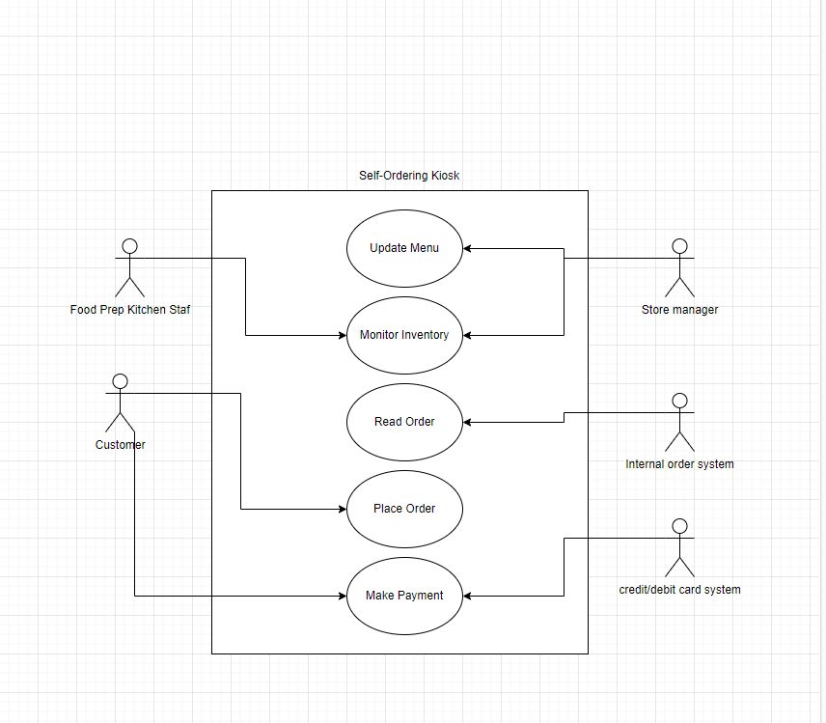

**Conceptual Model for the Self-Ordering Kiosk System at Amarah's Corner**

The self-ordering kiosk system begins when customers approach Amarah's Corner's stylish and welcoming kiosk. The interface welcomes them with vibrant images and an intuitive layout, guiding them through menu options. Customers easily navigate and personalize their pizza orders with real-time visualizations of sizes, toppings and add-on options. The system generates a clear summary of the order, ensuring accuracy before confirmation. Users then access seamless payment options, choosing from e-wallets or credit cards. Order details are transmitted to the backend system, allowing kitchen staff to receive and process instructions accurately. Customers will be notified via the kiosk when their order is ready for pickup, providing a seamless and efficient dining experience. The system integrates with the customer loyalty program, updating customer points after each purchase.

**Hardware:**

* Self-Ordering Kiosks
* Touchscreen Interface
* Payment Terminals (E-Wallet and Credit Card)
* Backend Servers
* Kitchen Display Screens

**Software:**

* User Interface Software for Kiosks
* Order Processing Software
* Payment Processing Software
* Backend System Software
* Loyalty Program Integration Software

**Network Components:**

* Local Area Network (LAN) for internal communication between kiosks, servers, and kitchen displays.
* Internet Connectivity for real-time updates, cloud synchronization, and payment processing.
* Security Protocols for data protection and customer privacy.
* Integration with Cloud Services for centralized data storage and analytics.
* Database Management System for storing and retrieving order details, customer information, and loyalty program data.

**References**

Baba, N., Mohd Shahril, A., & Hanafiah, M. H. (2020). Self-ordering kiosk usage and post-purchase behaviour in quick service restaurant / Noradzhar Baba, Aslinda Mohd Shahril and Mohd Hafiz Hanafiah. *Journal of Tourism, Hospitality & Culinary Arts (JTHCA)*, *12*(1), 1–17. <https://ir.uitm.edu.my/id/eprint/29154/>

‌ Arsalan, Syakieb, and Et Al. “Technology Adoption of Millennial Generations in Implementation of Self Ordering Machine in Fast Food Restaurant.” *Turkish Journal of Computer and Mathematics Education (TURCOMAT)*, vol. 12, no. 8, 24 Apr. 2021, pp. 556–560, turcomat.org/index.php/turkbilmat/article/view/2834/2430, <https://doi.org/10.17762/turcomat.v12i8.2834>.

Ishak, Farah Adibah Che, et al. “The Implementation of Self-Ordering Kiosks (SOKs): Investigating the Challenges in Fast Food Restaurants.” *International Journal of Academic Research in Business and Social Sciences*, vol. 11, no. 10, 26 Oct. 2021, pp. 1136–1150, hrmars.com/index.php/IJARBSS/article/view/11491/The-Implementation-of-Self-Ordering-Kiosks-SOKs-Investigating-the-Challenges-in-Fast-Food-Restaurants.

Na, Tae Kyun, et al. “Determinants of Behavioral Intention of the Use of Self-Order Kiosks in Fast-Food Restaurants: Focus on the Moderating Effect of Difference Age.” *SAGE Open*, vol. 11, no. 3, July 2021, p. 215824402110319, <https://doi.org/10.1177/21582440211031907>.

Samengon, Harnidah. “Consumer’s Motivations to Used Self Service Kiosk in Fast Food Restaurant/ Harnidah Samengon.” *Journal of Tourism, Hospitality and Culinary Arts*, vol. 14, no. 1, 1 May 2022, pp. 460–473, ir.uitm.edu.my/id/eprint/68318/.

Susandra Ketimin, et al. “An Insight of Customer’s Behavior Intention to Use Self-Service Kiosk in Melaka Fast Food Restaurant.” *The Journal of Technology Management and Technopreneurship (JTMT)*, vol. 9, no. 1, 2021, pp. 13–24, jtmt.utem.edu.my/jtmt/article/view/6020.

Xavier, Emmanuel Kaisser, et al. “Customer Satisfaction from the Self – Service Kiosks’ UI/UX and the Customer Continuance Intention to Use.” *E3S Web of Conferences*, vol. 426, 2023, p. 01083, www.e3s-conferences.org/articles/e3sconf/abs/2023/63/e3sconf_icobar23_01083/e3sconf_icobar23_01083.html, <https://doi.org/10.1051/e3sconf/202342601083>.